# Study questions chapters 1 and 2

1. **What are two factors that must be considered when choosing a computer case?**

* the number of internal drive locations
* the size of the motherboard and the power supply

1. **Which component controls the communications and interactions between the CPU and other components on the motherboard?**

* chipset

1. **Name at least three interfaces used for connecting video from computers to monitors.**

* DVI
* VGA
* HDMI

1. **Name at least three input devices for computers.**

* Keyboard
* Mouse
* Scanner

1. **Name at least three output devices for computers.**

* Monitor
* Printer
* Speakers

1. **What type of connector can be used to connect an internal hard drive to the motherboard?**

* SATA

1. **Which factors (at least 2) must be considered when replacing old RAM modules in a PC?**

* The new RAM must be compatible with the motherboard.
* The speed of the new RAM must be supported by the chipset.

1. **What is RAID 0?**

An array that strips data across multiple drives

1. **What is RAID 1?**

An array that mirrors data on a second drive

1. **What is a UPS used for?**

### It used to protect computer equipment against electrical power brownouts and blackouts by using a battery to supply a constant level of voltage

1. **What safety precautions should you take when working on a computer and its components?**

* Remove your watch and jewelry and secure loose clothing.
* Turn off the power and unplug equipment before performing service.
* Cover sharp edges inside the computer case with tape.
* Never open a power supply or a monitor with a built-in power supply.
* Do not touch areas in printers that are hot or that use high voltage.
* Know where the fire extinguisher is located and how to use it.
* Keep food and drinks out of your workspace.
* Keep your workspace clean and free of clutter.
* Bend your knees when lifting heavy objects to avoid injuring your back.
* Wear safety goggles to prevent damage to eyesight

1. **What is EMI and what could be a source.**

EMI is the electromagnetic interference.

Power lines could be a source of EMI.

1. **What is RFI and how could it affect a computer?**

RFI is the radio frequency interference.

It can affect the wireless signal in a network between a computer and the router.

1. **What are the 4 basic units of electricity and their units of measurement?**

* Resistance (Ohm, $Ω$)
* Current (Ampere, A)
* Voltage (Volt, V)
* Power (Watts, W)

1. **Name the parts numbered 1 to 10 on the motherboard:**

1. RAM slots 6. 4-pin CPU connector

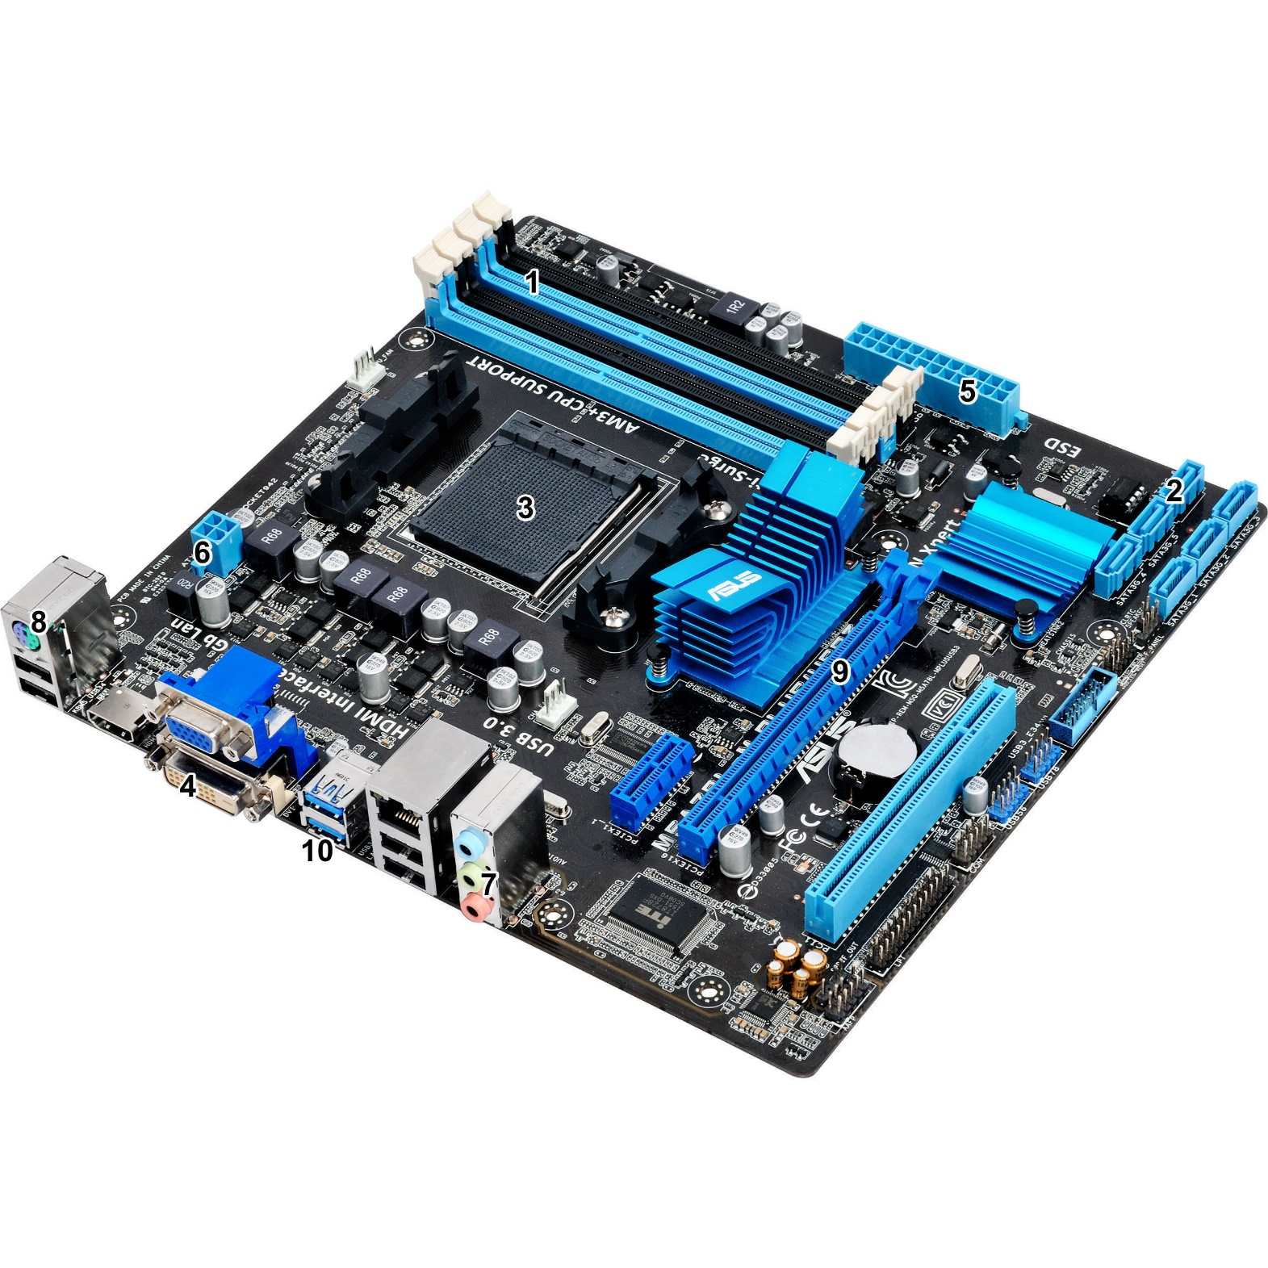2. SATA connectors 7. Audio ports

3. CPU socket 8. PS/2 ports

4. DVI connector 9. PCI express slot

5. 24-pin ATX power connector 10. USB 3 ports